Launch one ec2 instance in aws
- sign into aws console and then search for ec2 service
- In ec2 service, search for instances and create a instance by clicking launch instace
- Select amazon linux free eligible tiers
- Select t3.micro
- Select default security group
- Select .pem file for key pair file
- Then click on lauch instance it will create/launch an instance
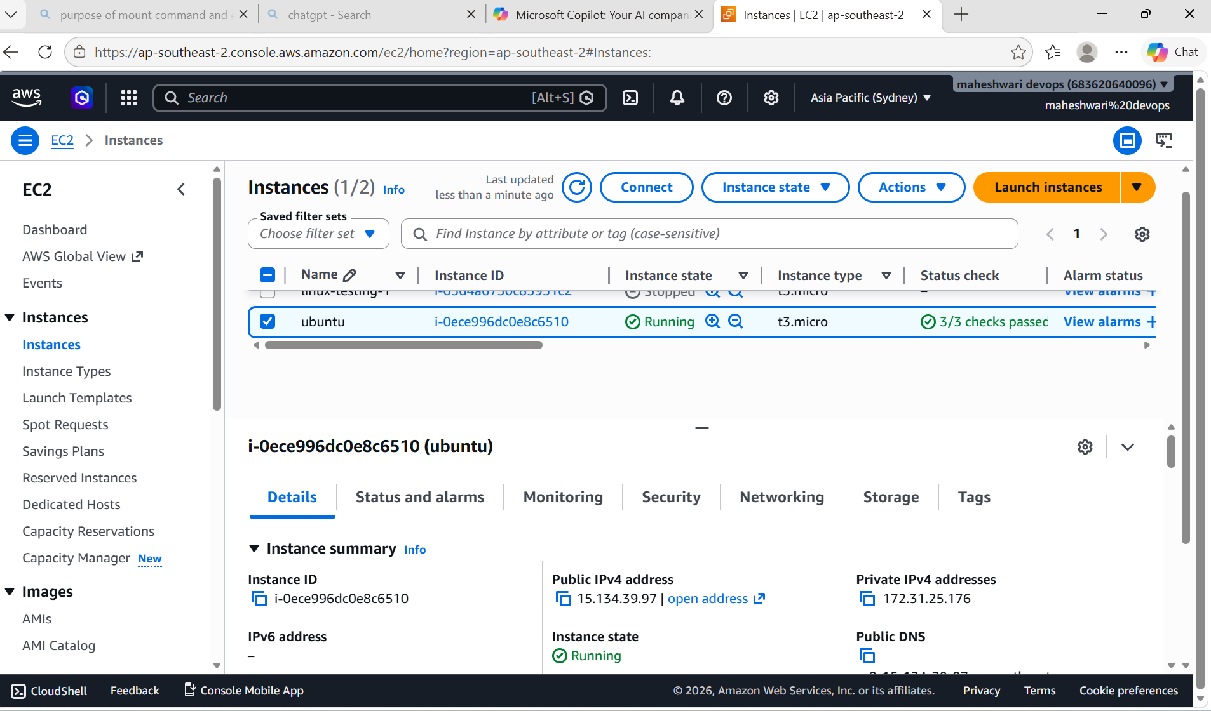

Jenkins
- Download Jenkins windows msi installer package from Jenkins website
- Before installing Jenkins we have download java in our system
- Download and install java jdk21 from java website
- Run downloaded java jdk21 in our system
- And then run Jenkins and install that by giving admin key that is done by giving the admin key path of java to Jenkins
- Then Jenkins will install in our system
- Configure jenkins with username and password in Jenkins website
- 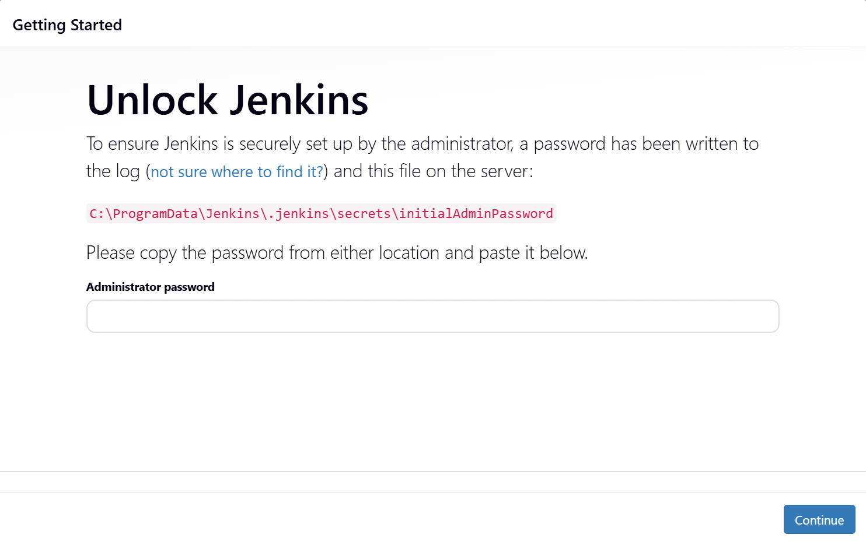
- 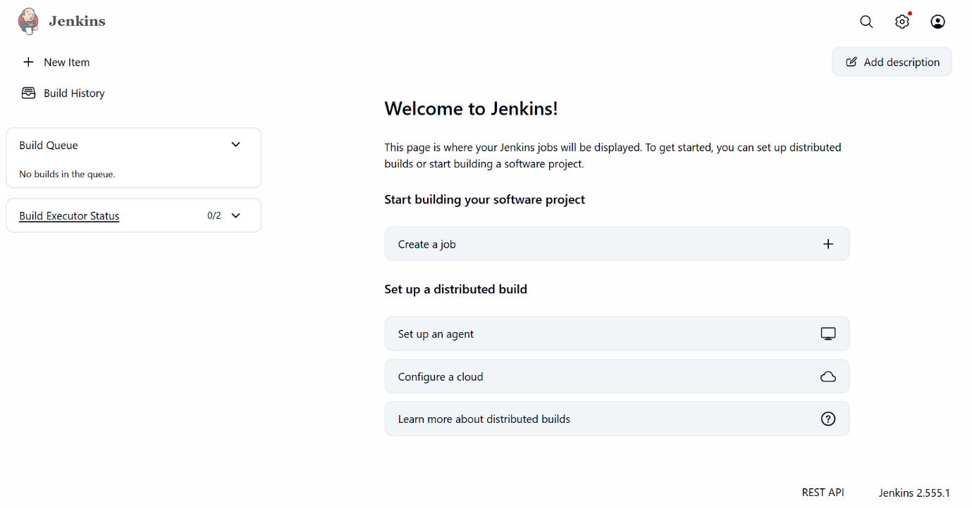

Apache tomcat
- Firstly open teminal and update
Sudo apt update
- Then install java by using the command
Sudo apt install default-jdk
- Check java version
Java –version
- Then search for the apache tomcat version with command
Sudo apt search tomcat
- Then we can install tomcat with command
Sudo apt install tomcat11 tomcat11-admin
- With this apache tomcat will be installed successfully
This server will run at 8080 port number and this is the default port number of apache tomcat
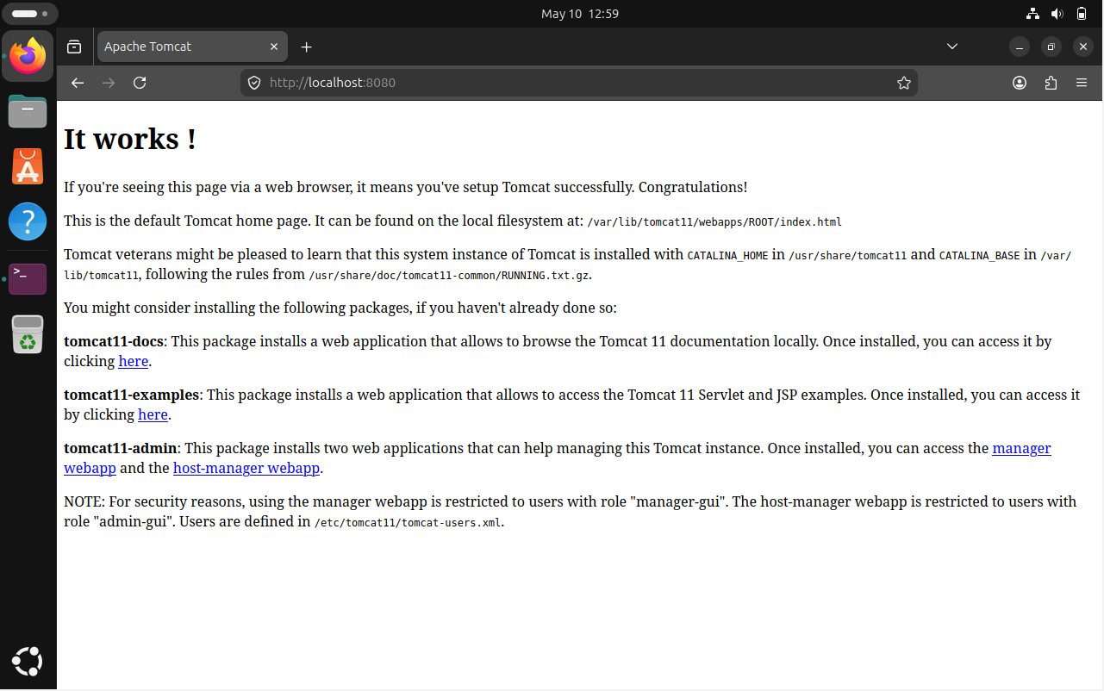

Docker
- Download the docker package from the docker website
- Then install the docker file and continue the setup
- After the completion of docker installation, we have to restart our computer to finish installation
- After restart create an account in the docker desktop and in the website
- Make sure that wsl is updated
- To update wsl, open cmd and give the command
Wsl – update
- Noe open desktop docker
